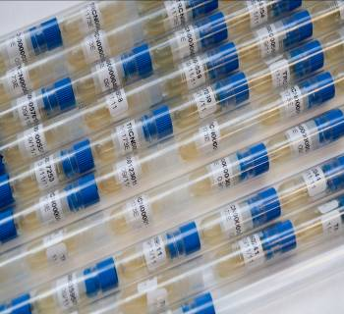
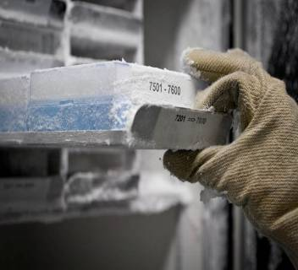
BCCM/LMBP PLASMID COLLECTION
Ghent University - Department of Biomedical Molecular Biology
Technologiepark 927
9052 Gent-Zwijnaarde BELGIUM
Tel.: +32 9 33 13 843 Fax: +32 9 33 13 504
E-mail: bccm.lmbp@irc.UGent.be
Website: http://bccm.belspo.be/about-us/bccm-lmbp
PLEASE PROVIDE US WITH THIS FORM PRIOR TO
THE DEPOSIT OF THE MICROBIAL HOST STRAIN
NUMBER OF DEPOSITS
- 1 to 5: complete one Accession Form per microbial host strain
- > 5: contact BCCM/LMBP to negotiate how to provide the data
ENCLOSED DEPOSIT ITEMS
I provide BCCM/LMBP with a clearly marked recipient containing the microbial host strain
petridish liquid culture
stab slant on dry ice
INFORMATION RELATED TO THE MICROBIAL HOST STRAIN
1. GENERAL INFORMATION
- Scientific name:
- Genetic description:
- Literature reference(s):
incl. PubMed/ISBN/doi
- Resident Plasmids:
- Resident Phages:
- EMBL/GENBANK accession number(s):
- Accession number(s) in other collections:
2. ORIGIN
- Isolated / constructed by own research group
- Isolation: Isolated by: Isolated from:
- Construction: Constructed by: Parental strain:
- Date of isolation/construction: Country of origin/construction:
Required for isolated strains only
Info related to the Nagoya Protocol (see Convention of Biological Diversity (https://www.cbd.int/abs))
Sampling agreement - Prior informed consent (PIC):
Yes Reference: Authority who issued the PIC:
Restrictions or conditions regarding Access and Benefit Sharing?
- Describe:
- Attach original documents if available
No Why not:
Not applicable Why not:
3. CULTIVATION CONDITIONS
- Medium:
LB-Lennox (10g/l tryptone, 5g/l yeast extract, 5g/l NaCl)
Other - Name:
- Composition:
- Resistance (# µg/ml): Choose an item. and Choose an item. and Choose an item. Other:
- Temperature: 37°C 28°C
- Special requirements:

4. RISK ASSESSMENT
- Pathogenicity:
pathogenic for Human? Yes • Risk class: No Unknown
pathogenic for Animal? Yes • Risk class: No Unknown
pathogenic for Plant? Yes • Risk class: No Unknown
Detailed information:
The microbial host strain has to be handled under biocontainment level *¹.
*¹ BCCM/LMBP accepts (recombinant) genetic material not exceeding containment level 2 following the EU directive 2009/41/EC and its updates (see also the Belgian risk group classification (http://www.biosafety.be/)).
- In case the microbial host strain is a GMO:
Cloned DNA fragment: chromosomally integrated episomal
Detailed information:

AGREEMENT FOR DEPOSIT IN THE PUBLIC COLLECTION FREE OF CHARGE
Name of the depositor:
Institution:
Address:

Tel.:
E-mail:
I agree to deposit the microbial host strain in the public BCCM/LMBP collection following the conditions mentioned in the BCCM MAA (http://bccm.belspo.be/services/maa)*². I authorize BCCM/LMBP to catalogue the data online and to distribute samples to third parties under the conditions mentioned in the BCCM Material Transfer Agreement (http://bccm.belspo.be/services/bccm_mta.php).
*² a Prior Informed Consent (PIC) or a valid document equated to PIC is not required for host strains for plasmids
I need to be kept informed about distributions outside my own department or outside the departments in which BCCM/LMBP is embedded, namely UGent-DBMB and VIB-IRC, until 5 years after deposit.
Extra restrictions or another Material Transfer Agreement can exceptionally be negotiated with the BCCM/LMBP manager.

Date:
Signature of the depositor or authorized person*³:
*³ in case the depositor is a legal entity
name of authorized person:

