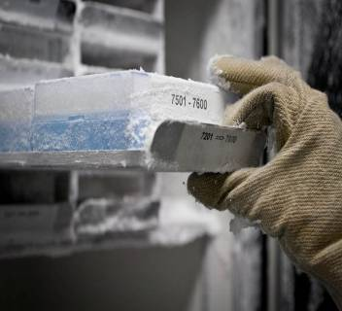
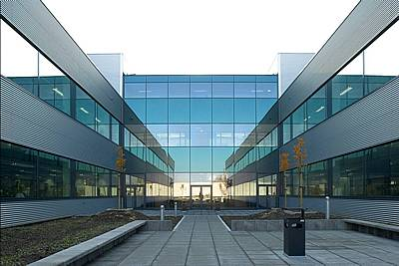
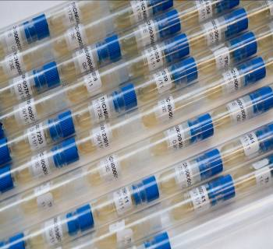
BCCM/GeneCorner Plasmid Collection
Ghent University - Department of Biomedical Molecular Biology
Technologiepark-Zwijnaarde 71, 9052 Gent, Belgium
E-mail: bccm.genecorner@ugent.be Tel.: +32 (0)9 33 13 843
Website: https://bccm.belspo.be/about-us/bccm-genecorner Twitter: @BccmCollections https://www.genecorner.ugent.be LinkedIn: BCCM Collections
PLEASE PROVIDE US WITH THIS FORM PRIOR TO
THE DEPOSIT OF THE MICROBIAL HOST STRAIN
NUMBER OF DEPOSITS
- 1 to 5: complete one Deposit Form per microbial host strain
- > 5: contact BCCM/GeneCorner to negotiate how to provide the data
ENCLOSED DEPOSIT ITEMS
I provide BCCM/GeneCorner with a clearly marked recipient containing the microbial host strain
petridish liquid culture
stab slant on dry ice
INFORMATION RELATED TO THE MICROBIAL HOST STRAIN
1. GENERAL INFORMATION
- Scientific name:
- Genetic description:
- Literature reference(s):
incl. PubMed/ISBN/doi
- Resident Plasmids:
- Resident Phages:
- EMBL/GENBANK accession number(s):
- Accession number(s) in other collections:
- Application:
2. ORIGIN
- Strain constructed by: on date:
- Country of construction:
- Parental strain:
Information related to the application of the Nagoya Protocol (NP) under the Convention on Biological Diversity (CBD): https://www.cbd.int/abs/. This protocol implements the Access and Benefit Sharing (ABS) principle and requires recording some basic information.
Only recombinant host* strains can be deposited at BCCM/GeneCorner. Natural isolates should be deposited at one of the other appropriate BCCM collections.
*: GeneCorner considers a host strain as a strain having peculiar features that are necessary to propagate the plasmid or to make use of the special characteristics of the plasmid.

3. CULTIVATION CONDITIONS
- Medium:
LB-Lennox (10g/l tryptone, 5g/l yeast extract, 5g/l NaCl)
Other - Name:
- Composition:
- Resistance (# µg/ml): Choose an item. and Choose an item. and Choose an item. Other:
- Temperature: 37°C 28°C
- Special requirements:
4. RISK ASSESSMENT
- Pathogenicity:
pathogenic for Human? Yes • Risk class: No Unknown
pathogenic for Animal? Yes • Risk class: No Unknown
pathogenic for Plant? Yes • Risk class: No Unknown
Detailed information:
The microbial host strain has to be handled under biocontainment level *¹.
*¹ BCCM/GeneCorner accepts (recombinant) genetic material not exceeding containment level 2 following the EU directive 2009/41/EC and its updates (see also the Belgian risk group classification (http://www.biosafety.be/)).
- In case the microbial host strain is a GMO:
Cloned DNA fragment: chromosomally integrated episomal
Detailed information:
AGREEMENT FOR DEPOSIT IN THE PUBLIC COLLECTION FREE OF CHARGE
Name of the depositor:
Institution:
Address:

Tel.:
E-mail:
Website:
I agree to deposit the host strain in the public BCCM/GeneCorner collection following the conditions of the BCCM Material Deposit Agreement (https://bccm.belspo.be/legal/mda)*²*³. I confirm that all information is correct and trustworthy. I authorize BCCM to catalogue all data in this Deposit Form online and to distribute samples to third parties under the general conditions of the BCCM Material Transfer Agreement (https://bccm.belspo.be/legal/mta) and any other conditions if applicable*³.
I agree that my personal data processed in the framework of this deposit will be handled in conformity with the personal data protection statement of the BCCM-consortium (https://bccm.belspo.be/legal/disclaimer).
*² A Prior Informed Consent (PIC) or a valid document equated to PIC is not explicitly required for host strain constructs.
*³ Adaptations to the MDA/MTA as well as extra restrictions for distribution can exceptionally be negotiated with the BCCM/GeneCorner manager.
I need to be kept informed about distributions outside my own department until 5 years after deposit.
Date: Signature of the depositor or authorized person*⁴:

*⁴ in case the depositor is a legal entity, name of the authorized person:

