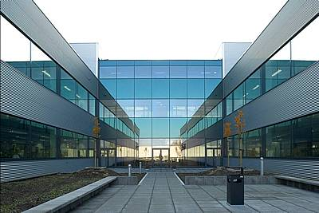
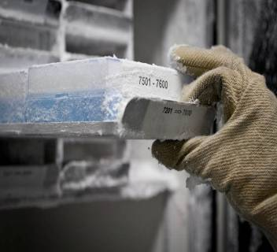
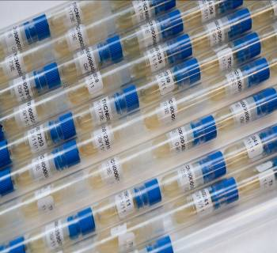

BCCM/GeneCorner Plasmid Collection  Ghent University - Department of Biomedical Molecular Biology  Technologiepark-Zwijnaarde 71, 9052 Gent, Belgium  Tel.: +32 9 33 13 843  E-mail: bccm.genecorner@ugent.be  Website: https://bccm.belspo.be/about-us/bccm-genecorner  https://www.genecorner.ugent.be/ | Twitter: @BccmCollections  LinkedIn: BCCM Collections
PLEASE PROVIDE US WITH THIS FORM PRIOR TO THE DEPOSIT OF THE PLASMID
NUMBER OF DEPOSITS
- 1 to 5: complete one Deposit Form per plasmid
- > 5: contact BCCM/GeneCorner to negotiate how to provide the data
ENCLOSED DEPOSIT ITEMS
I provide BCCM/GeneCorner with:
- a clearly marked recipient containing
plasmid DNA (minimum 1 µg)* or a plasmid-carrying culture
aqueous solution precipitated petridish liquid culture
evaporated on filter stab slant on dry ice
* preferably plasmid DNA in a 1,5 or 2 ml Eppendorf tube
- a sequence file a circular map, if available
INFORMATION RELATED TO THE PLASMID
1. GENERAL INFORMATION
- Plasmid name:
- Plasmid type: Natural plasmid Recombinant plasmid
- Plasmid reference(s):
incl. PubMed/ISBN/doi
- Insert / cloned gene(s):
incl. EMBL/GENBANK accession number(s)
- Backbone: Name:
Source:
- Application:
- ORIGIN
- Plasmid isolated/constructed by: on date:
- Country of origin/construction:
Required for natural plasmids
Information related to the application of the Nagoya Protocol (NP) under the Convention on Biological Diversity (CBD): https://www.cbd.int/abs/. This protocol implements the Access and Benefit Sharing (ABS) principle and requires recording some basic information listed below.
Sampling agreement - Prior informed consent (PIC):
Yes Reference: Authority who issued the PIC:
Restrictions or conditions regarding Access and Benefit Sharing?
- Describe:
- Attach original documents if available
No Why not:
Not applicable Why not:
3. HOST FOR PRESERVATION AND DISTRIBUTION
- E. coli K12 DH5α E. coli K12 x B DB3.1 E. coli K12 NEB Stable
- Other: Scientific name:
Genetic description:
Literature reference(s):
incl. PubMed/ISBN/doi
4. CULTIVATION CONDITIONS HOST/PLASMID
- Medium:
LB-Lennox (10g/l tryptone, 5g/l yeast extract, 5g/l NaCl)
Other - Name:
- Composition:
- Resistance (# µg/ml): Choose an item. and Choose an item. and Choose an item. Other:
- Temperature: 37°C 28°C
- Biocontainment level*¹: L1 L2 L1 in microbial host strains, L2 in mammalian cells
- Cultivation remarks:
*¹ BCCM/GeneCorner accepts (recombinant) genetic material (as isolated material or in a host) not exceeding containment level 2 following the EU directive 2009/41/EC and its updates (see also the Belgian risk group classification (http://www.biosafety.be/)).
5. PLASMID FEATURES  - Size (bp):  - Replication origin(s):  - Promoter(s):  - Ribosome binding site(s):  - Selection marker(s):  - Terminator(s): |  | OPTIONAL  if sequence file is provided  or backbone is well-known
6. ADDITIONAL INFORMATION  - How constructed:  - Accession number(s) in other collections:  - Remarks: |  | OPTIONAL
AGREEMENT FOR DEPOSIT IN THE PUBLIC COLLECTION FREE OF CHARGE
Name of the depositor:
Institution:
Address:

Tel.: E-mail:
Website:
I agree to deposit the plasmid in the public BCCM/GeneCorner Plasmid Collection following the conditions of the BCCM Material Deposit Agreement (https://bccm.belspo.be/legal/mda)*²*³. I confirm that all information is correct and trustworthy. I authorize BCCM to catalogue all data in this Deposit Form online and to distribute samples to third parties under the general conditions of the BCCM Material Transfer Agreement (https://bccm.belspo.be/legal/mta) and any other conditions if applicable*³.
I agree that my personal data processed in the framework of this deposit will be handled in conformity with the personal data protection statement of the BCCM consortium (https://bccm.belspo.be/legal/disclaimer).
*² A Prior Informed Consent (PIC) or a valid document equated to PIC is currently not explicitly required for recombinant plasmids
*³ Adaptations to the MDA/MTA as well as extra restrictions for distribution can exceptionally be negotiated with the BCCM/GeneCorner manager.
I need to be kept informed about distributions outside my own department until 5 years after deposit.
Date: Signature of the depositor or authorized person*⁴:

*⁴ in case the depositor is a legal entity, name of authorized person:

